Julie Lange Groth
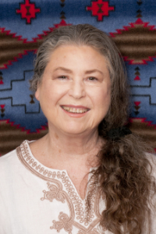
Julie Lange Groth, founder of Ravens Drum, is a shamanic healer and teacher who leads ceremonies and runs retreats. Healing What Grieves You is her second book. Her first book, Life Between Falls: A Travelogue Through Grief and the Unexpected, has helped thousands. She is a member of the Foundation for Shamanic Studies and the Society for Shamanic Practice.
For more information, contact Julie through www.JulieLangeGroth.com or www.CapeHouseBooks.com.

